Project : Investment Portfolio and Asset Track

### **PO : Erick Sixto Hernandez Palomo**

## Participants :

* [Insert Participants]

## Problem Statement:

The client needs a single source of truth for their investments. They want to create, manage, modify and delete all their investments in Salesforce.

They currently have investments in different platforms and industries like Cryptocurrencies, Stocks, Governmental Debt, Lending and Precious Metals.

Right now, the client has to manage and track their investments in multiple places like spreadsheets and notes. They would like to have all that information in Salesforce.

Also, they want to integrate everything in one single place so they could create reports and dashboard about their investments.

Right now the client is using [TradingView](https://tradingview.com/) as its source for following the stocks and crypto prices. They would like to avoid the extra step of going to trading view to see the current price of a Stock or Cryptocurrency (found by its unique ticker), they would like to just see the price in real time in Salesforce. Also, if it's possible a small graph of the price behavior for the last 3 months.

Regarding the fix-rate investment like the Governmental Debt, Lending and Bonds, they would like to have a way to define an interest rate, an end-date for the investment and that way track their fix-rate investment in one single place.

For the precious metal investment (which right now is only Silver), the client currently types the date and amount of metal they bought and at which price. A way to integrate these investments into Salesforce is needed.

Even when this becomes a single source of truth, division into categories, industries, and types of investment is necessary. They would like to differentiate investments into Fix-Rate, Cryptocurrencies, Stocks and Precious Metals.

With all this said, an easy way for seeing the current portfolio status is needed. Things like the portfolio asset division, the amount invested in the different assets, a list of recent investments, a list of the fixed-rate investments that will end sooner and more widgets are required.

Without saying, the checking of the portfolio usually is done on the fly via their mobile phones. The solution should be mobile friendly.

## Current Pain Points:

* Multiple sources of truth where the investments are stored.
* Need of going to trading view to see the current price of a variable-rate asset.
* Lack of meaningful reports and dashboards.
* Lack of a tool to distinguish each type of investment easily.
* Lack of mobile friendly solution for easily viewing their portfolio status.

### Solution: Note: Specify the clouds and licenses required for the proposed solution.

[INSERT SOLUTION DESIGN DESCRIPTION]

# Solution Architecture Diagram (High level diagram)

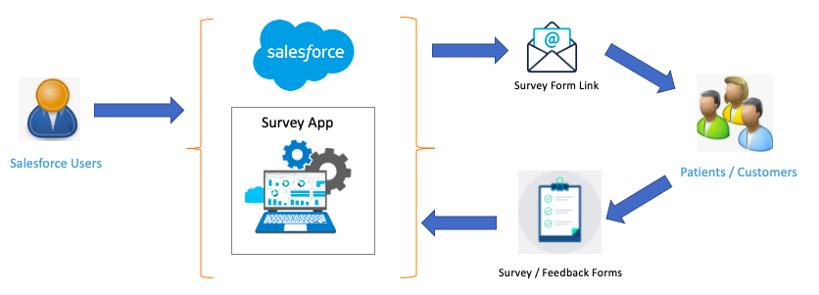

Example Architecture Diagram...

[Explanation]

# Project Scope

|  |  |  |  |
| --- | --- | --- | --- |
| **Functional Area / EPIC** | **Tasks / Activities** | **Category** | **Assumptions** |
| Define & Design | -System Design  -Collect User stories  -Create Supporting Object Model  -Feature implementation, UAT and QA | Configuration & Setup | TTUHSC is an academic healthcare institution seeking a Patient Survey, Feedback, and Improvement Solution to enhance its efforts in providing the best patient experience |
|  |  |  |  |
|  |  |  |  |
|  |  |  |  |

# Timeline & Procedure

[Implementation Timeline]

# Risks Management

[Insert Risk Table with Assumptions, Risks, Responsible, Mitigation Plan]